# Experimental report template （English）

**Experimental Report**

**For ZUST**

|  |  |
| --- | --- |
| **Course：** | **《EC》Lab Class** |
| **School：** | **SEM** |
| **Class：** | **International economics and trade 191** |
| **Name：** | **Ran Danping** |
| **Student ID：** | **1190697078** |
| **Instructor：** | **Guangming Yang** |

# Experiment 1: B2C/C2C selling and shopping

### 1.1 B2C e-commerce analysis

1. Let’s take Huawei and Xiaomi as examples, shown below are their website pages.

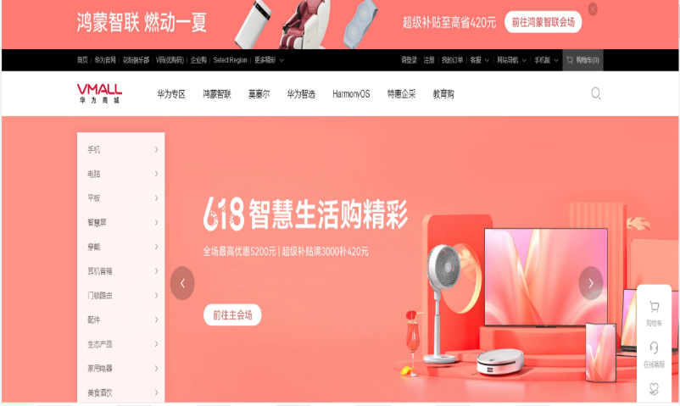Comparing the two interfaces, we can find that their overall layout is similar. There is a search interface, product classification, product image display and so on.

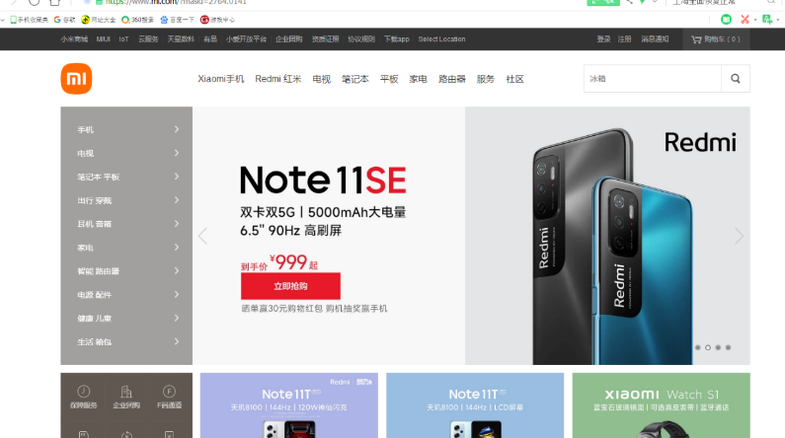Xiaomi self-operated e-commerce products are difficult for users to browse because there are few categories; It is also because users use self-supporting products with a purpose, so users usually "look for" behavior, so the function of the home page usually recommends theme products and creates popular models. Self-operated malls operate brands, and self-operated e-commerce that can develop and expand have successfully created brand images; Therefore, highlighting the brand in product design will build trust with users, improve transformation, and achieve differentiated design with other e-commerce.

After logging in to huawei website, we can see that the navigation bar of Huawei website is divided into seven firstlevel columns, including industry insight, Solutions and Products, Technical Support, About Huawei, Media Center, Join Huawei, and Huawei Mall. Under each level column and set a number of secondary columns. For example, there are three secondary columns about Huawei: company introduction, sustainable development and company publications. The media Center has four secondary columns: News, Joy of Connection, Social Welfare and management. Huawei mall is directly connected to the home page of Huawei Mall.

The functions, the processes of registration and the steps of purchasing goods of these two website are quite similar is also similar. If you want to buy something on either of them, you just need to search for it and add it to your chart, filling in your address information and then pay for it.

**2.Understand the importance of payment and distribution system for B2C model.**

For online business, the traditional payment method requires the buyer to go to the bank or post office to handle complicated remittance business; If the method of cash on delivery is adopted, it will bring certain risks to the merchants. Therefore, online payment platform is born in this demand. As an important part of e-commerce, online payment has become an inevitable trend of the development of online commerce. Distribution is the mainstream circulation channel. Compared with direct marketing, less investment, high efficiency, the enterprise's own human resources and management capacity requirements. Therefore, it has stronger applicability and universality. The application of third-party payment platform effectively avoids the risks of return and exchange, integrity and other aspects in transaction structure, and provides complete support for merchants to carry out B2B, B2C and even C2C transactions as well as other e-commerce services and other value-added services. Network distribution applies to most products, suitable for network distribution of products suitable for transportation, long-term consumption, convenient after-sales, quality assurance.

**3.The development status and trend of B2C electronic commerce:**

China&apos;s B2C ecommerce market is growing rapidly, with the transaction volume of major B2C service companies doubling. B2C ecommerce development momentum is so fierce, thanks to: Internet users have formed the habit of online shopping, at the same time, Internet users pay more attention to credit and brand shopping; C2C enterprises to B2C mode transformation; Foreign trade enterprises focus on domestic sales, commodity supply capacity enhancement; Consumers have more spending power; The whole ecommerce environment is gradually becoming perfect and the whole industrial chain is becoming mature. The following is to analyze the development status of China&apos;s B2C market:  
B2C e-commerce favored by investor.

B2C hot, also by the risk of investment in particular. Dangdang and mecox Lane have become the first batch of B2C listed enterprises in China. The funds raised by the two companies will be used to expand their product categories and build platforms and logistics systems. The listing of McCauley and Dangdang enhanced the industry&apos;s confidence in the development of online retail and promoted the B2C investment boom. Data shows that China&apos;s e-commerce has received more than $1 billion in investment and financing. Among them, JINGdong Mall has been invested by five companies, including Wal-mart, with a total investment of 500 million DOLLARS. Letao received rmb200m in financing;

**4. In view of the success of the B2C enterprise, you must analyze the characteristics of the B2C system in the system planning and pattern management, and summarizes the successful elements of the model.**

B2C business models can be divided into four categories: Middlemen mode Middlemen mode refers to the enterprise does not have its own production base, just as middlemen selling goods on the Internet According to the variety of goods on sale, can be further divided into comprehensive and vertical type, such as dangdang and B2C companies such as amazon variety of products Vertical B2C company is specialized in one type of goods The third party trading platform model E-commerce enterprises to establish website provides trading platform, not participate in product sales and distribution process This mode will move into the enterprise directly to the trading desk with consumers, greatly save the cost of self-built e-commerce site in enterprises, while e-commerce enterprises by providing business platform for value-added income (such as open a shop advertising fee Pay for services such as) the pattern model is Tmall mall Jingdong mall and other manufacturer direct sales model Through self build e-commerce platform, product manufacturers to provide their products directly to consumers, it is divided into two modes: one is manufacturers selling products on the Internet, only the other one is manufacturers selling products on the Internet, and in the real shops, namely Online and offline mode Manufacturers establish their own e-commerce platforms, so that products can be directly sold to users, reduce intermediate links, greatly reduce marketing costs, so that manufacturers and consumers get more benefits.

**Tasks:**

Step1:Open the Xiaomi website and find the register page:

Step2: Fill in the basic personal information and set the payment method to finish up the register.

Step3:Choose a phone on the page

Step4:add the product to the cart

Step5:Write down the address and select related delivery service 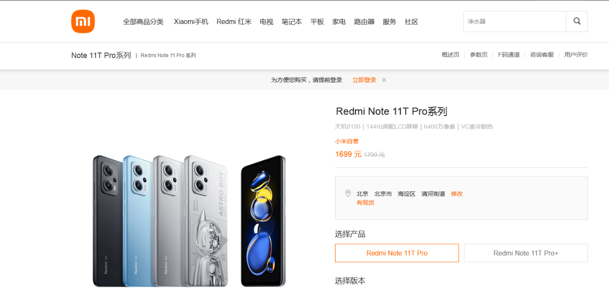

Step6:Comfirm the information and price, then submit the deal and pay the bill.

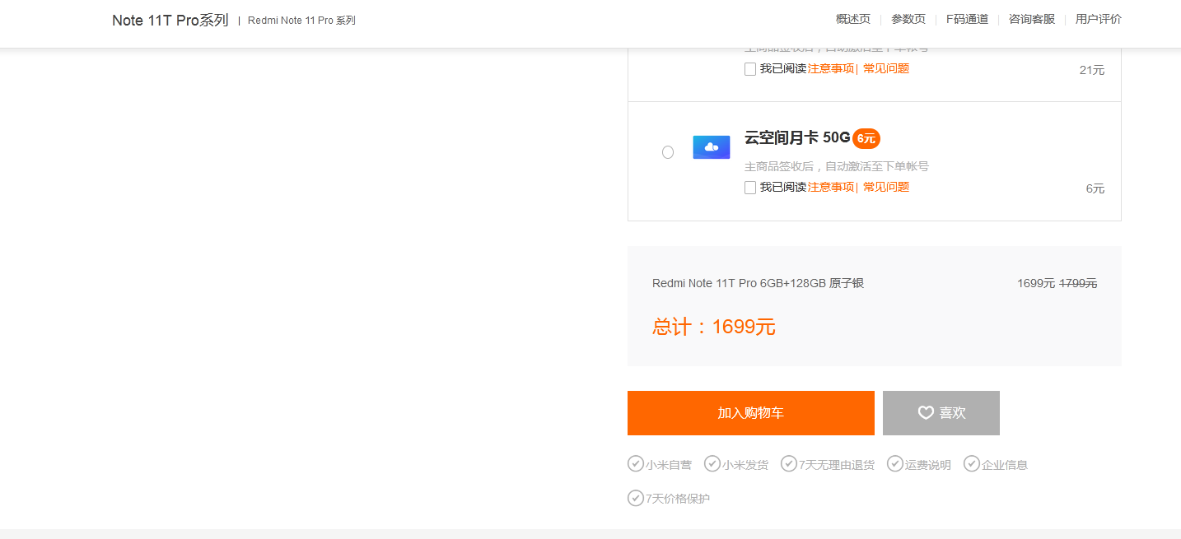

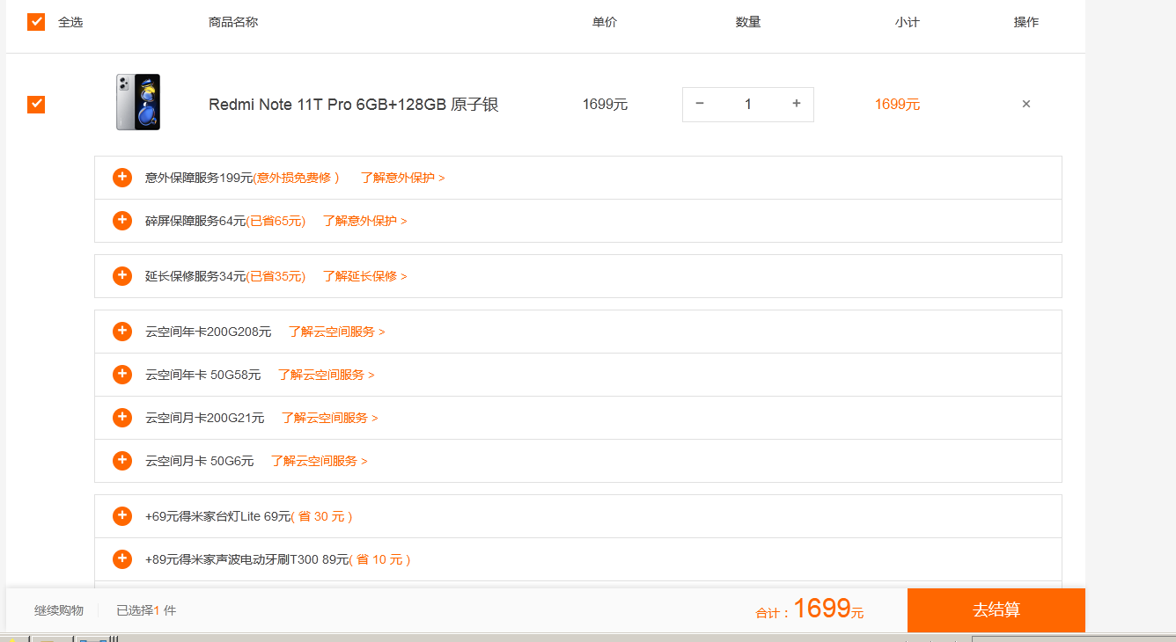

**1.2 B2C shopping on amazon.com or** **https://www.amazon.ca/**

1. Visit amazon.com

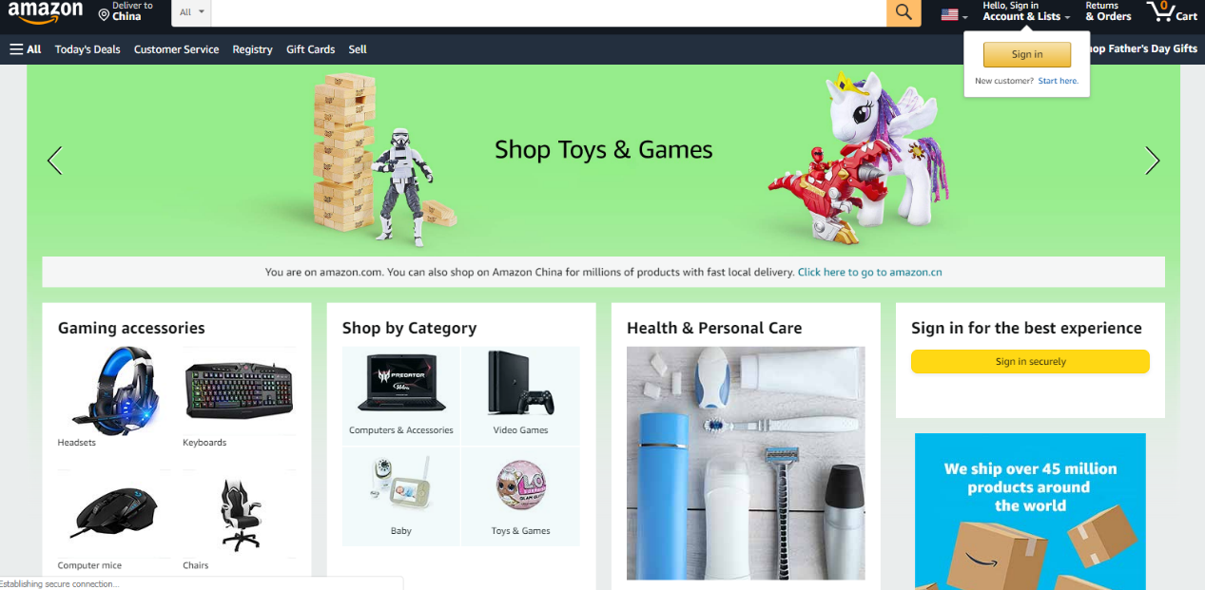  
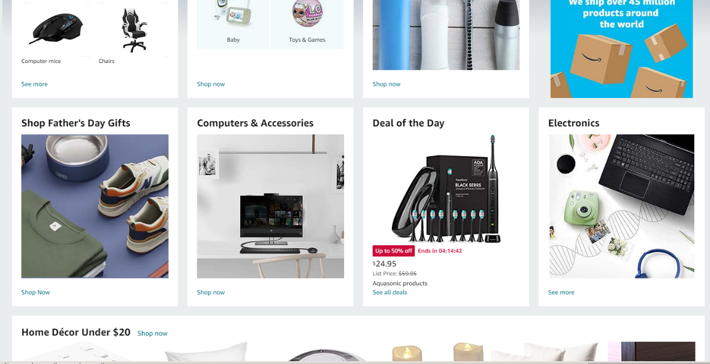

Step2. Let’s take dress for an example. Choose an electric toothbrush.

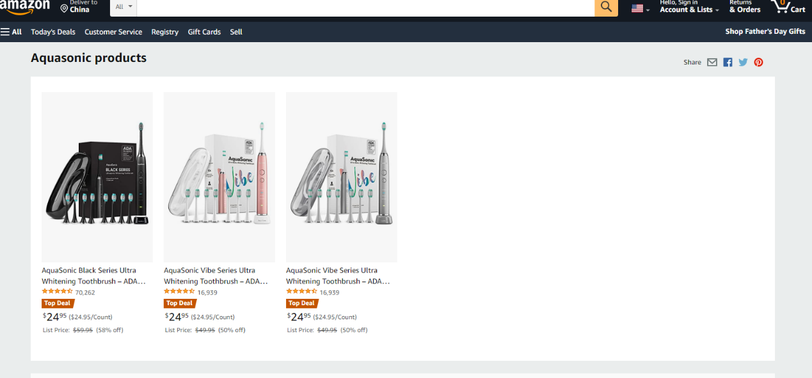

Step3.add it into your cart.

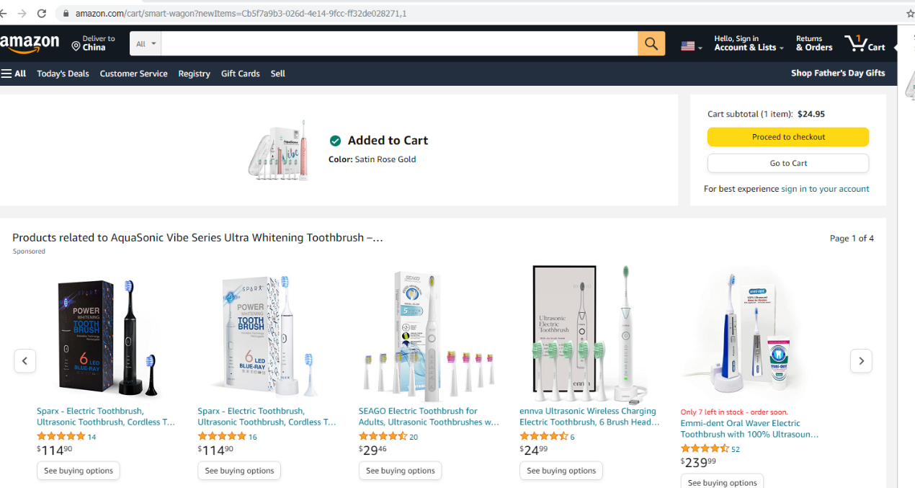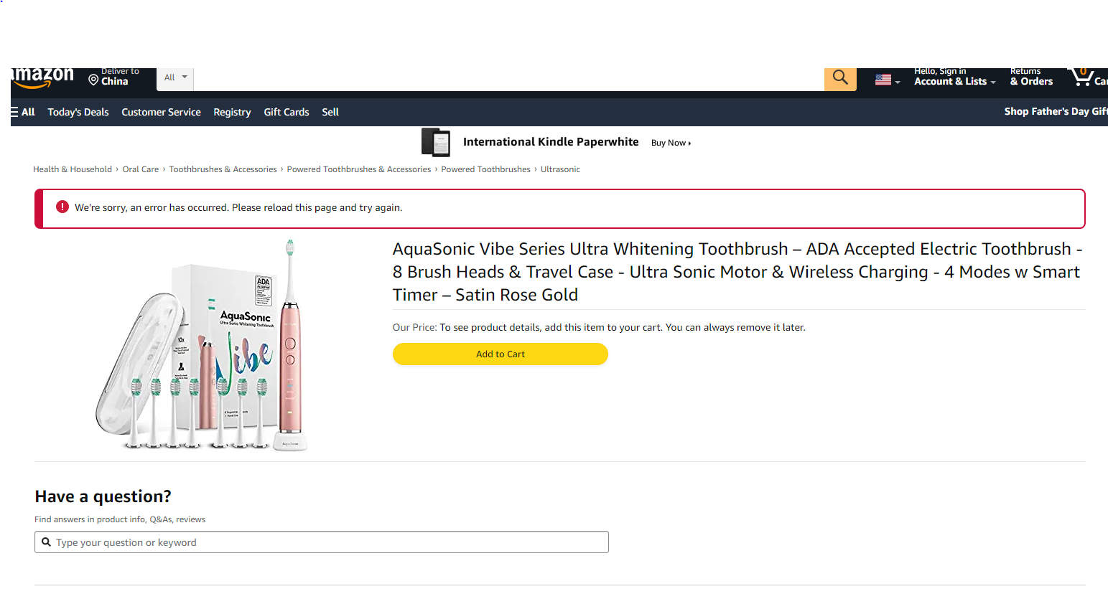

Step4.After popping out of this page,we need to register.

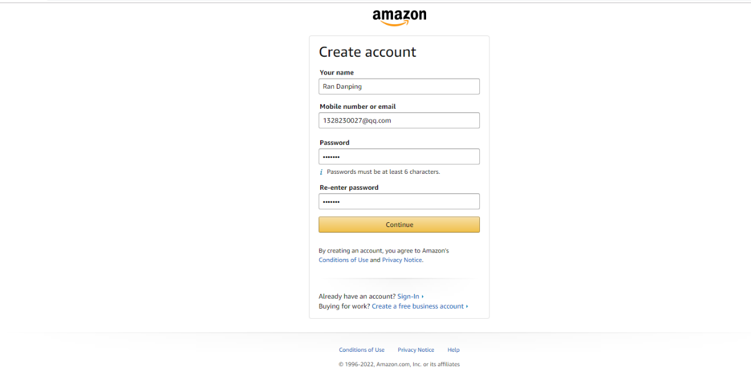

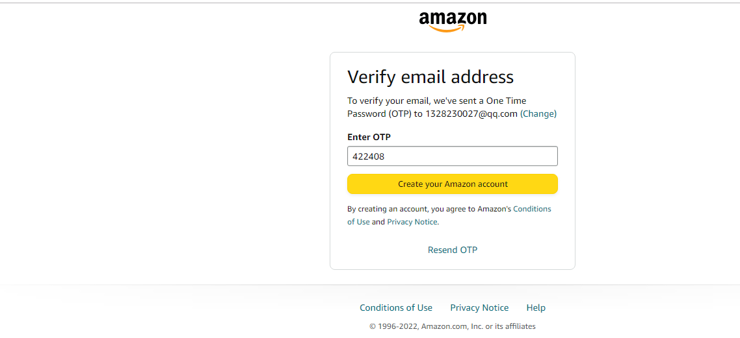

Step5.Fill the information in this page. Select or add or edit a shipping address, choose a shipping speed, choose your payment options

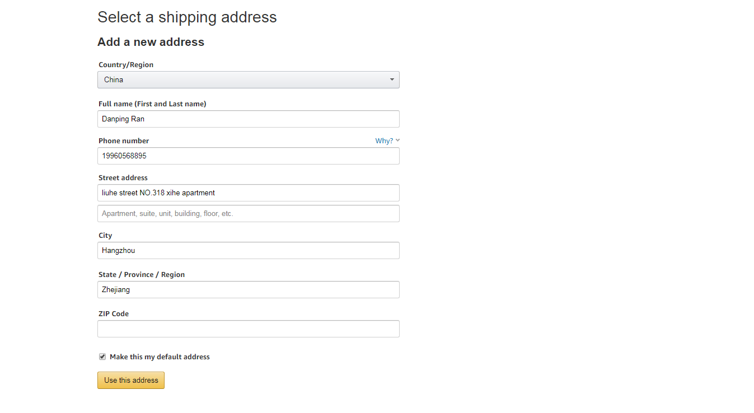

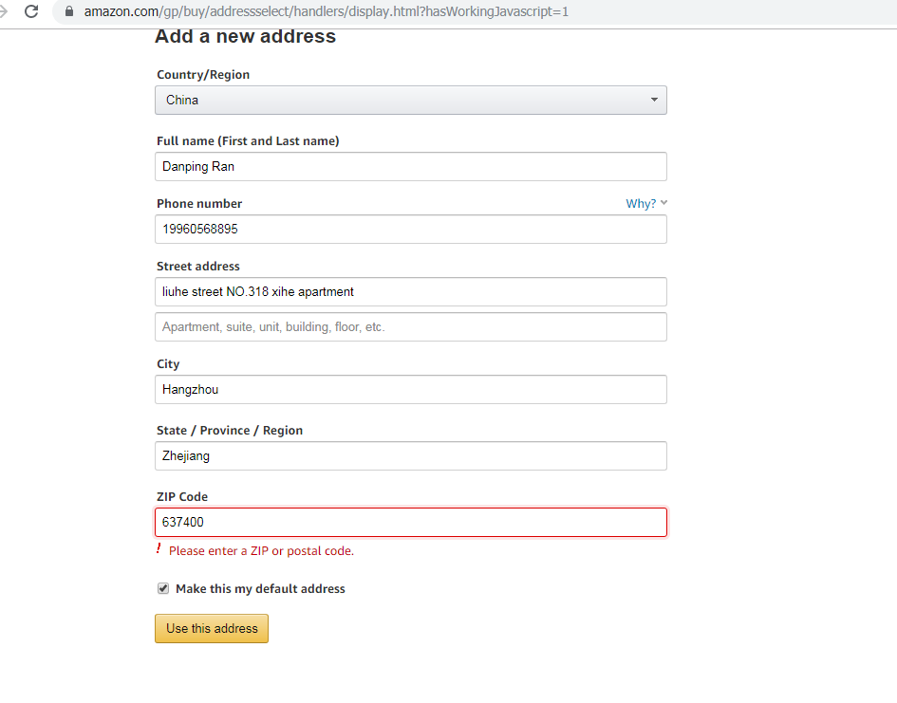

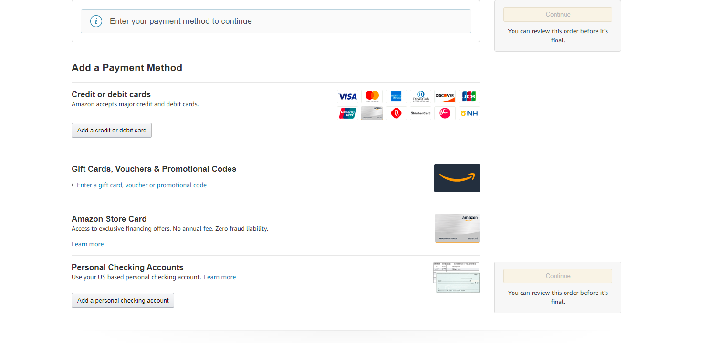

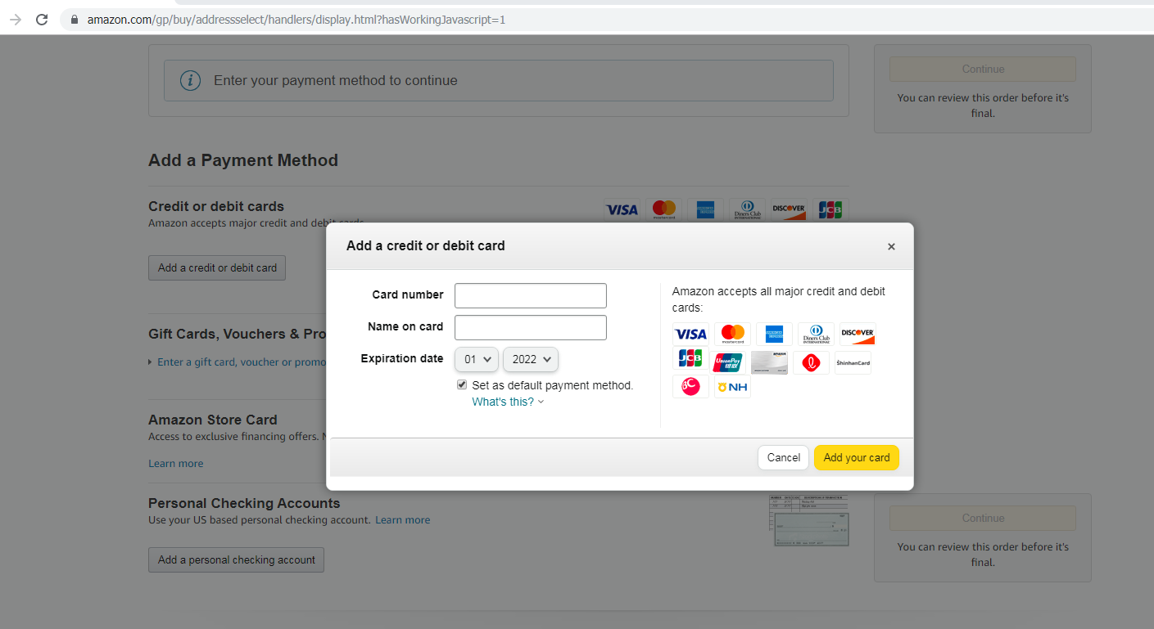

1.3 B2C Selling on Amazon.com

**1 Set up a seller account**

When you become a seller, you need to create a seller account. It's easy - you just need to register.

You can use your customer account to start selling, or you can create a new Amazon seller account with your business email.

|  |
| --- |
| Step1.Visit amazon.com and click “Sell    Step2.Click “Sign up” to register a sell’s account. Then click “Create your Amazon account” and fill the information in the second page below.      Step3.After you finish the information, click ”next” and fill the OTF you received in your email  Step4. Now you have your sell’s account, fill the information and you can start your business. |

**1.4 Questions**

1. Explain part of the shopping process of B2C EC and problems (including registration, authentication, transaction, order processing, communication, distribution, payment, Trust, etc.

The general process of shopping of B2C is that, register a new account → log in → Open app or website → select product → use discount → add cart→ use allowance → checkout online → generate order → backend system to process order → order out → confirm receipt → complete

1. Consumers use their own computers to search for products they want to buy through the Internet.

2. Consumers browse online, buy the required goods and put them into the shopping car, fill in the order form automatically generated by the system, including the name, quantity, unit price, total price, etc., and indicate the detailed information of when and where the goods will be delivered and to whom.

3. Contact relevant stores through the server and get a response, and inform consumers of the unit price of the goods purchased, the amount of payment due, delivery and other information.

4. After confirming the above information, the consumer will load and open the electronic wallet in the system, input his/her password and take out the electronic credit card for payment.

5. The electronic credit card number is encrypted and sent to the corresponding bank. The online store receives the purchase order and waits for the payment confirmation from the bank.

6. If the payment is not successful, it means that the money on the credit card has exceeded the overdraft limit or is on the blacklist, and the consumer can not use the card. The consumer can open the electronic wallet again, take out another electronic credit card, and repeat the above operations.

7. If the credit card is verified by the bank to be valid and authorized, the online store can pay for the goods, while the selling store keeps the financial data of the entire transaction and presents an electronic receipt to the consumer.

8. Upon completion of the above transaction, the e-shop will deliver the goods to the consignee specified by the consumer at the designated place in accordance with the electronic order provided by the consumer.

**The problem:**

Unlike shopping in a physical store or talking directly to a service provider, e-commerce has inherent limits on interaction. At the product level, customers must make decisions based on images, product descriptions, and reviews. There may be problems with the wrong goods or not meeting expectations.

Much of the customer service provided by e-commerce people is strictly digital, such as forms on websites or emails, often with a long lag between filing a complaint and receiving a response.

Product uncertainty: While e-commerce can save efficiency and cost, you often can't see, touch, feel, or smell a product before you buy it. If you are not satisfied with the product, return and exchange costs are higher.

The movement of business to electronic channels has been criticized for its restrictions on personal interaction. While companies have taken steps to create personal web tools and accounts and offer personalized product recommendations, e-commerce still lags behind face-to-face business transactions in this area.

**Strengths**

1)It is convenient and fast, with increased service advantages. Through online shopping malls, consumers can shop without leaving home, saving time and energy. And in terms of after-sales service, online stores can list the common problems that consumers often encounter

The list is placed on the web page, and consumers can directly query if they have any questions. Online after-sales service can be carried out 24 hours a day, and the methods are flexible and diverse. In addition to the traditional telephone method, complaints can also be made in the BBS forum of the shopping mall, e-mail can be sent, and QQ and other chat tools can be used to communicate directly with the staff of the online shopping mall. The application of these service means can not only better satisfy consumers, but also promote the emotional exchanges between buyers and sellers, and increase consumers' loyalty to online shopping malls.

2)Compared with traditional commerce, B2C infrastructure construction costs are reduced. Retail enterprises in traditional commerce need to spend a lot of infrastructure costs in renting shops, decorating stores, configuring shelves and so on. B2C is an online shopping mall, which only needs a virtual home page. The list of goods is listed on the web page one by one. Consumers can browse the details of goods with a mouse click, and then place an order, which can reduce the costs of a large number of store decoration and rental shops. Moreover, the business radiation range of traditional retail stores is very small. If you want to get closer to consumers, you must build more stores and increase the cost of infrastructure construction. Online shopping malls only need a home page to make it convenient for all kinds of consumers to log in.

3)realize direct one-to-one sales, reduce operating costs and prices. Compared with traditional commerce, B2C often needs several levels of wholesale to reach retail, and each link in the middle will inevitably increase the cost of goods. B2C directly sells goods to consumers on the Internet, which can bypass many wholesale links and reduce the price of goods. Consumers can get more benefits from buying the same goods, and the marginal profit margin of online shopping malls can also be increased.

**Weaknesses**

1)The way of B2C website can not meet the consumer psychology of users. Based on traditional consumption habits, consumers are more inclined to see physical and experiential consumption, and still have doubts about virtual online shopping. In addition, consumers are unlikely to be in the virtual store.

You can experience any shopping atmosphere in the shopping mall. Compared with traditional shopping malls, you can't see the rolling flow of people, dazzling entertainment and leisure facilities, or hear the lively background music. B2C websites are almost identical, too monotonous, and the business model has not gone out of new space. Almost all of them attract consumers by displaying content on the page and reducing prices. The business model is too thin and monotonous. The innovation of business models such as pricing, delivery and even communication is not strong.

2)The integrity system has not been improved. The complexity of B2C e-commerce remote transaction determines that it needs to have an integrity system covering the whole country. This is obviously far beyond the scope of e-commerce enterprises, and needs the help of the third party and the government. So far, only a few cities such as Shanghai have established relatively perfect local integrity companies to collect and process personal credit data such as public utility fees and bank loans. In more cities, the credit system is still blank, so it is difficult to establish the credibility of online shopping.

3)Paying too much attention to price has affected the profits of B2C enterprises and weakened the attention of enterprises to other links. The current positioning of B2C is not very accurate. Most B2C are positioned at low prices, reducing the space for use. B2C should be positioned at increasing

Go up to the service. If it is positioned at low prices, it may never get out of trouble. Most of today's B2C customers are over 20 years old and under 50 years old. They have received higher education. Their first concern is not price, or not just price, but convenience and time saving. Therefore, B2C is only positioned at low prices. Without better value-added services, B2C is difficult to attract its consumer groups.

4)Imperfect logistics distribution, lack of funds and difficult turnover. China's B2C enterprises generally have less investment and have not established their own logistics distribution system. China's logistics distribution level is backward, which makes the logistics distribution cost too high, resulting in the "price advantage" of B2C success. In addition to specialized online stores, consumers generally hope that the more abundant the goods in online stores, the better. In order to meet the needs of consumers, B2C e-commerce enterprises have to spend a lot of money to enrich the supply. The vast majority of B2C e-commerce enterprises are supported by venture capital. After the e-commerce operation environment is established, there is little money left in the account.

**Opportunities**

1)At present, most B2C enterprises do not provide consumers with convenient and fast information feedback channels. The emergence and application of real-time interactive communication tools can not only shorten the distance with consumers, grasp the needs of consumers at the first time, but also reduce costs and improve benefits. The application of im (specifically communication) tools such as Alibaba Wangwang, eBay's Skype and QQ patting has opened up the communication channel between B2C e-commerce enterprises and consumers. In addition, the participation of third-party payment manufacturers and the cooperation between banks and B2C enterprises provide guarantee for online payment and payment security.

2)Flexible operation and characteristic operation. B2C e-commerce enterprises such as fantong.com, yunwang.com, tencent.qq, and jiuzuan.com have made great efforts in products and services, operated flexibly, looked for features, and found a suitable profit path in B2C e-commerce. At present, B2C e-commerce has a variety of commodity forms, which can meet the different needs of consumers. With the development of online entertainment and leisure, virtual goods are also popular. The special existence form of virtual goods avoids the bottleneck of e-commerce such as distribution, and brings a greater opportunity for B2C e-commerce enterprises.

3)The emergence of various forms of e-commerce alliances can enable B2C e-commerce enterprises with few resources to use their existing core resources more effectively in exchange for the required resources and continuously strengthen their competitive advantages. B2C e-commerce enterprises are only located in the part of sales and after-sales service in the value chain. They are not engaged in commodity research and development, production and distribution. When they trade commodities with consumers, they need to "exchange resources" with other enterprises in the value chain. The situation of the alliance can enable B2C e-commerce enterprises to focus on their own core business and strengthen their competitiveness.

**Threats**

1)Fierce competition, there are a lot of competitors in our e-commerce market (JD.com, Amazon)

2) In the process of consumption, the consciousness of protecting personal information is weak, which causes consumers to receive fraudulent information and brings some influence to users.

3)The low price competition pressure is big, the merchant profit ability is low. Many merchants are good at competition through low prices, market disruption, to obtain competitive advantage, but also lead to other merchants to reduce sales prices in order to obtain profits, the formation of vicious competition, so that many merchants reduce revenue.

4)The strategic direction of Logistics Distribution Service ability promotion slow

3. Discuss B2C EC revenue models.

In general, most of the business revenue realized by China's B2C websites is created by enterprises themselves in the process of dealing with the value chain .Its main sources are

1. Product sales revenue model

Most B2C websites use product trading as their main source of revenue. This B2C website can be subdivided into two kinds: sales platform website and independent sales website

A. Selling platform websites.

The website does not sell products directly, but provides B2C platform services for merchants, and makes profits by charging virtual store rental fees, transaction fees and franchise fees. Taobao B2C shopping platform ----- Taobao Mall is a typical example. Taobao provides taobao Mall as a B2C platform, charging merchants to join Taobao Mall a certain fee, and charging different service fees and deposits according to different service levels.

B. Independent sales website.

Different from sales, independent sales requires a website to sell products directly. Compared with the sales platform, the operation cost is higher, so it is necessary to develop product supply channels by itself, and build a complete storage and logistics distribution system or develop third-party logistics franchisees to outsource logistics services.

2.network advertising revenue model.

Online advertising revenue model is a common model in the Internet economy. B2C websites provide products or services free of charge to attract enough "attention" so as to attract advertisers to invest in advertising and make profits through advertising. Compared with traditional media, advertisers have unique advantages in placing advertisements on the Internet: on the one hand, the efficiency of online advertising is relatively high, generally charging according to the number of clicks on the advertisement. On the other hand, B2C websites can make full use of their own products or services to measure different categories of marketing groups, which is also very attractive to advertisers.

3. Fee-based membership revenue model

B2C website provides members with convenient online franchise registration procedures, real-time user purchase behavior tracking records, accurate online sales statistics and perfect information security certificate. The paid membership theme is the theme membership of the website, the number of members to a certain extent determines the final income of the website through members. The size of the site's revenue mainly depends on its own promotion efforts. For example, the network can timely hold some preferential activities and give more preferential membership price to charging members, which is different from free members, so as to attract more long-term customers.

4. Indirect revenue model of the website

In addition to profits that can turn the value they create into reality, companies can also achieve profits through other links in the value chain.

A. Online payment revenue model

When B2C online payment has enough users, you can start to consider the problem of obtaining income through other sources. Take Taobao as an example, nearly 90% of Taobao users pay, bringing taobao a huge profit space. Taobao can not only charge certain transaction service fees through Alipay, but also make full use of the huge funds generated by users' deposits and payment time difference for other investment profits B. Website logistics revenue model

The transaction scale of B2C e-commerce in China has reached tens of billions of yuan, resulting in a large logistics market. Take logistics as its own service, the service of the website, the website can not only occupy the profit of logistics, but also make the value created by users get added value. However, there is a big difference between the logistics industry and Internet information services. B2C websites need to establish a pilot distribution system because the cost of taking logistics as their own service is very high, which requires a strong financial backing, while most websites are difficult to do.

4. Discuss B2C EC promotion plan.

The first step website structure integration and SEO.

Optimizing the beginning of a successful marketing campaign must have enough attractive marketing products, and then carry out effective marketing promotion to start a comprehensive integrated promotion we can help you do:

1. Optimization of website frame structure and page content

2. the design of META tags, page Title (Title) selection

3, optimize the density of keywords on each page

4, the effectiveness of page links

5. Introduction of effective content on the website

6. make a reasonable site map: make a simple list of website functions and modules, show the key modules

The second step is search engine promotion

After targeted optimization, you can start a comprehensive range of external promotion, which began at home and abroad to the major search engines and classified directory site included, the current domestic and more than 80% of the site traffic from the major search engines, waiting for the major search engines at the same time, take the initiative to submit to the China search alliance, search site search application, strive for more sources of search, and the root According to the development of different stages, stages of each search engine submitted included.

The third step is to publicize and promote the effective content of the website

B2B platform for user groups is the enterprise or individual, with a nature of work and brought by the search engine users multifarious variety, the purpose is not strong, and what we need is a valid traffic, finally generate high loyalty of user groups, therefore, effective content website propaganda, for the users to the site to promote their extensive publicity is also our important channel.

**1.4.5 Give your opinion on future of B2C E-commerce.**

The core to solve the problem of e-commerce is how to excavate their own unique value and give full play to their own advantages. Vertical e-commerce enterprises are easier to exploit their own unique value by taking advantage of their professional advantages. How do large-scale comprehensive e-commerce enterprises exploit their unique value? Large categories and popularity are the basis for large integrated retailers, but I think it is difficult for retail to generate sufficient profit margins in the e-commerce environment. The platform services, which take advantage of platform advantages and aim at the key links of the industry, will become an important source of profits for large-scale comprehensive e-commerce. Using huge traffic to provide a marketing platform for merchants, Taobao has been doing this, and self-owned e-commerce is also actively developing platforms. Due to early development and expansion, infrastructure, such as self-built logistics and information technology, is obviously ahead of small or vertical e-commerce. With the expansion of scale, its cost-performance advantage will gradually emerge, and it can provide logistics and information technology services for other businesses. Another typical industry platform product is online payment, such as Alipay, Ten pay, and the recent emergence of Yifubao, both rely on online payment tools generated by e-commerce platforms, which can also generate considerable profits. To develop asset-light, low-risk and high-profit businesses by taking advantage of large platforms and technologies is what excellent IT companies should do, rather than a simple price war and marketing war.

1. **Experiment 2: B2B platform trading**

**2.1 selling on alibaba.com**

**Tasks:**

1. Analyze the design and the features of the alibaba.com, understand the operating effect, and describe the structure of functions of this platform, including publishing products, online transaction, promotion, logistics, and payment.

The overall page is relatively simple, with the structure of left middle right (the left is quick navigation, the middle is advertising and promotion activities of various brands and products, and the right column is personal homepage information). The main color of Alibaba website is red and white. It adopts the combination of graphic and text. The products are diversified and comprehensive, mostly for fast moving products, with various sources and their own payment methods

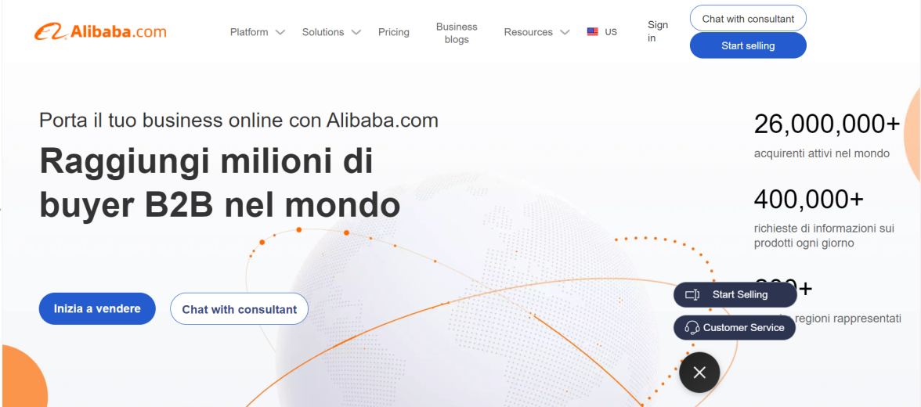

Step1: Sign in

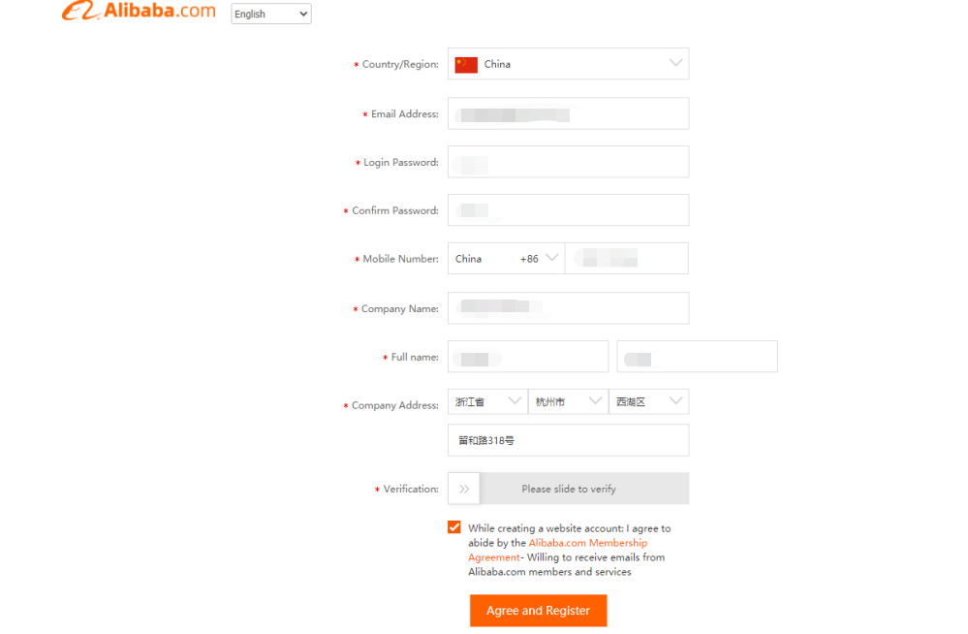

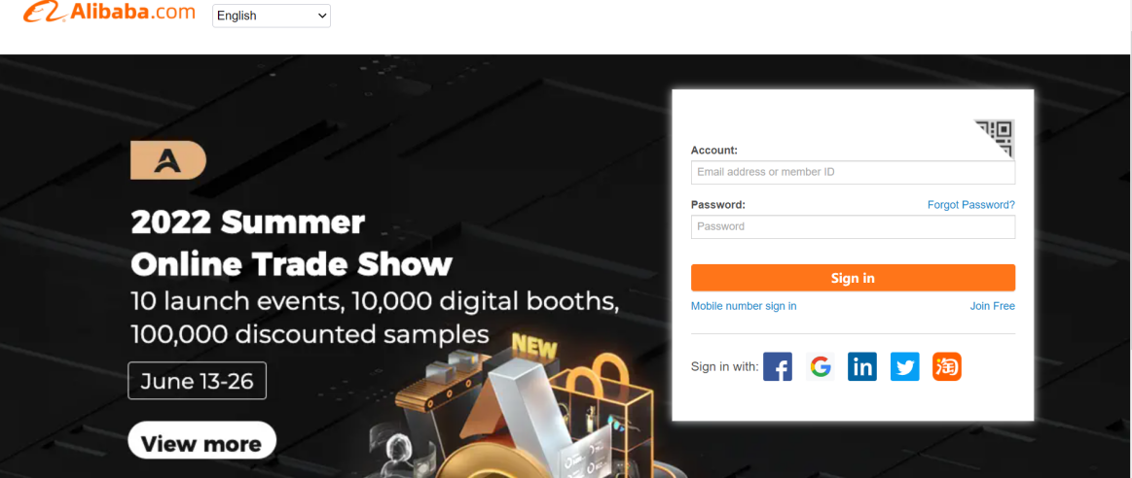

Step2: Search product on search box

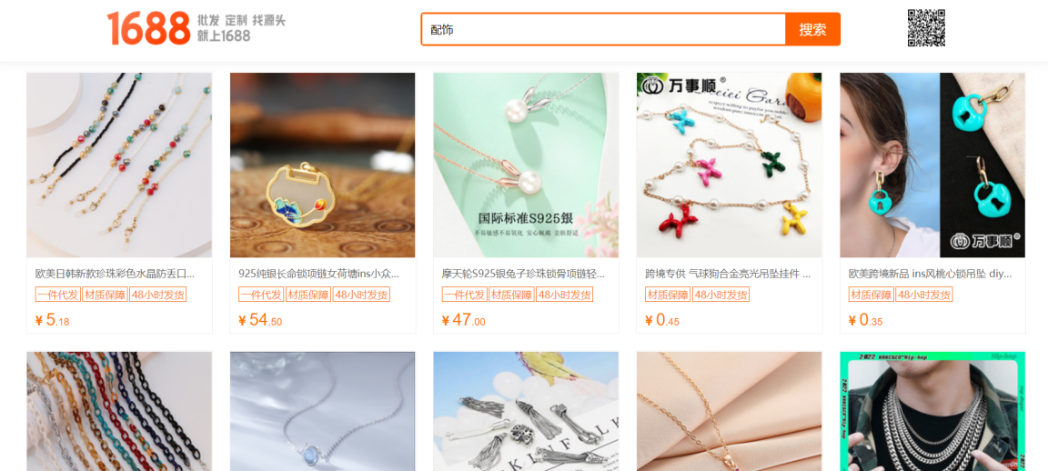

Step3: View all the products and compare, choose the favourite one

Step4: Choose the product property

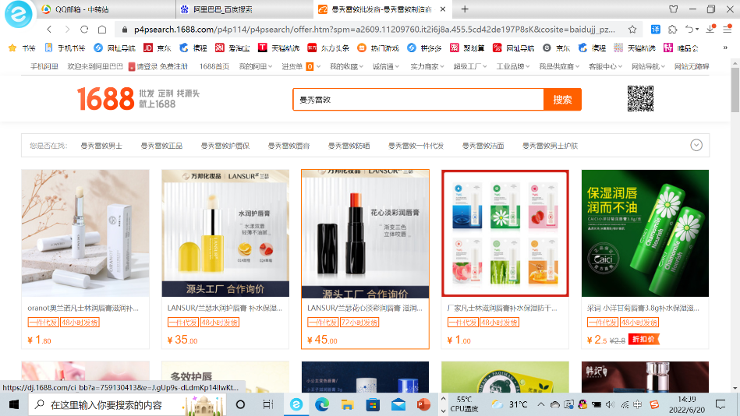

Step5: Edit address and choose the delivery service

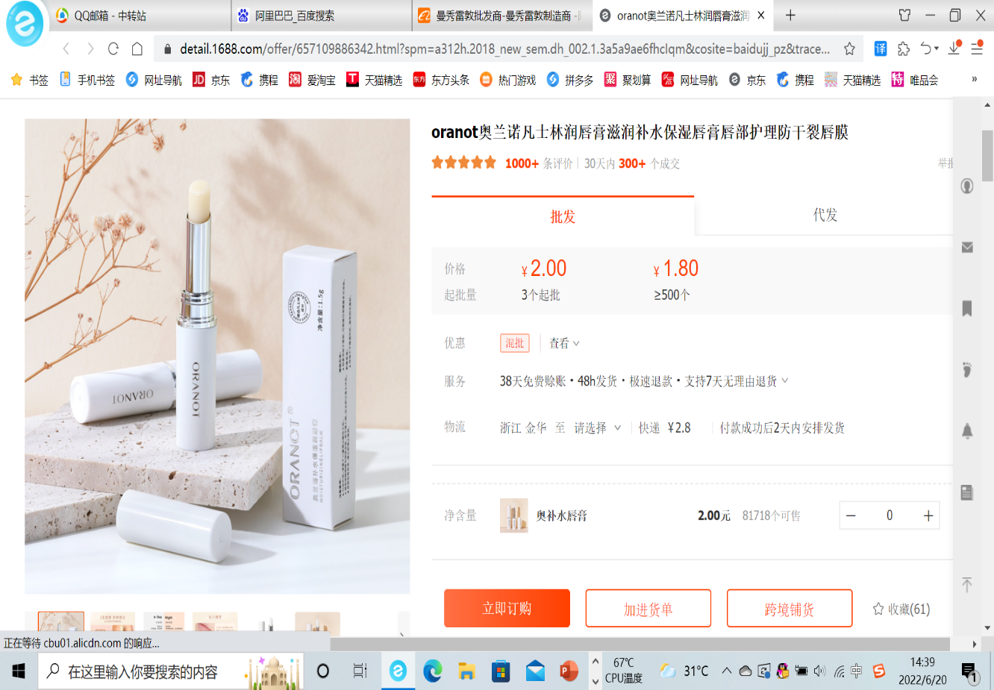

Step6: Contact with supplier. Comfirm the price and submit the deal, make the payment.

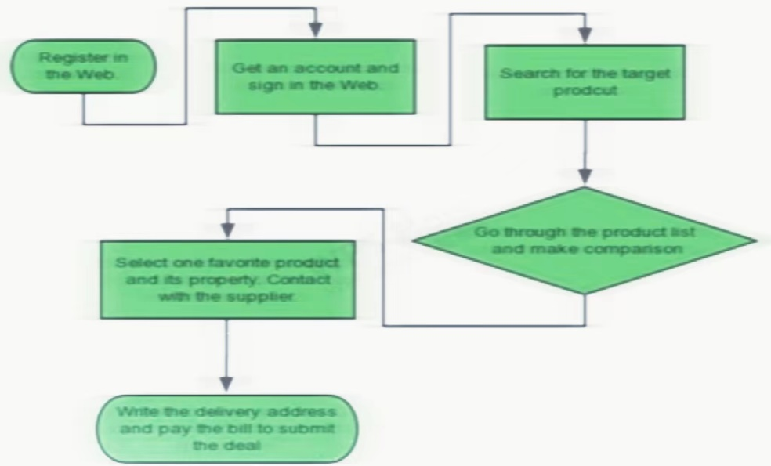

2. Answer the following questions:

How do I buy on Alibaba.com?

Step 1.Find products/suppliers you are interested with on Alibaba.com.

Step 2.Contactspecific Supplierto negotiate the product/order details(such as product price, shipping method, shipping cost etc.)

Step 3.After all order details confirmed,

How do I find products/suppliers on Alibaba.com?

1)  Searchwithkeywords;

2)  Search withimages;

3)  Post RFQ;

Method 1: Search with keywords.

Go to Alibaba.com,enter keywords to search for the products/suppliers you want.

Search for Verified Suppliers

With RFQ, you can:

1.Get quotes for your customer request

2.Let the right suppliers find you

3.Closedeals with oneclick . In every product detail page, there is an“Addto Favorites”button.

 Pleaase click on it to add to "My Favorites"

How can I find the suppliers contact information?

To check supplier&apos;s contact info(email, phone),

 please search for the product first, find the product preferred,

and click the suppliers; company name to its online shop.

Click Contact to check the suppliers contact info.

Alibaba.com is a business to business tradingplatform for buyers and suppliers

 to exchange business information .Most of the members on Alibaba.com are manufacturers, trading companies, or resellers whotrade in large quantity order.

As you know, the product price/shipping cost aremainly based on purchase quantity and shipping methods.

Therefore, you are suggested to contact the specific supplier tocheck and negotiate the price and other details,

 such as MOQ, shipping cost forthe product that you are interested in.

Clickheretoknow how to contact the supplier.

If you want to get an approximate shipping cost, please click "Get shipping quote" on the productdetail page,

fill details about your order,

 click "Get Quote", the system will estimate the cost to ship it viaAlibaba.com Logistics.

You could also select a quote to start a logistics order through Alibaba.com.

**2.3 Learn about the following platform:（For international students ,you can omit 1,2,4,6,8. ）**

1、[www.1688.com](http://www.1688.com)

It is Alibaba's website. The page is relatively simple as a whole, with a left middle right structure (quick navigation on the left, advertising and promotion activities of various brands and products in the middle, and personal homepage information in the right column). The main color of Alibaba website is red and white. It adopts the combination of graphic and text. It looks very fresh and clear. The main function is to help members find buyers, suppliers, partners and online sales and purchasing. Most of the users are dealers

2、<http://www.hc360.com/>

Its structure is similar to that of Alibaba. The difference is that there is a "purchase market" module under the homepage of huicong.com to show the purchase and quotation of products in a rolling way, as well as modules such as "characteristic market", "industry source of goods" and "industry market" to facilitate the settled businesses to find the key source of goods. Different modules are distinguished by different colors, which is more concise in vision. Most users are manufacturers

1. <http://www.chemnet.com/>

These two websites are both CHEMENET websites. It's easy to be dazzled when entering the web page just now, and the information is too dense. The main color is blue. There are many advertisements for different products on the page, but they are not classified by category. There is some confusion. The home page shows the navigation of the website and provides the search of chemical products. In the middle of the page is information about the chemical industry, such as raw material price, factory rental, industry trends, etc. It is positioned as a comprehensive chemical service provider.

4、<http://seller.dhgate.com/>

5、<http://www.dhgate.com>

These two websites are both DHGATE website, same as CHEMENET its website has Chinese version and English version, which is more international. Compared with other websites as a whole, the homepage content is less and very simple, and it can find the target very quickly. Most different from other websites, dunhuang.com has positioned itself as the world's leading cross-border e-commerce export platform, mainly serving small and medium-sized enterprises. Based on foreign trade e-commerce, its business model is different from the traditional membership service model. Instead, it adopts the mode of free membership and successful transaction commission.

6、<http://china.chemnet.com/>

7. http://www.globalsources.com/

Global Sources is a B2B multi-channel international trade platform and a major promoter of bilateral trade in Greater China. Global Sources provides sourcing information for professional buyers and comprehensive marketing services for suppliers. Using a combination of graphics and text, the information is clear, the pages are neat and easy to find the target products. Unlike other platforms, the consumer base of Global Sources Network focuses on four major industries: furniture and gifts, hardware, electronics and textiles.

8、**<https://cn.made-in-china.com/>**

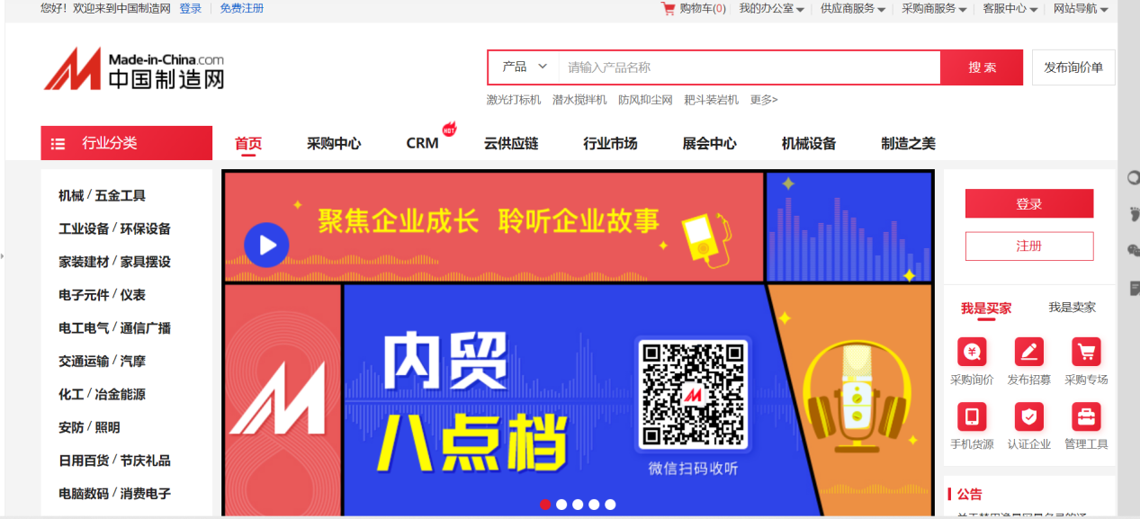

9、**<http://www.made-in-china.com/>**

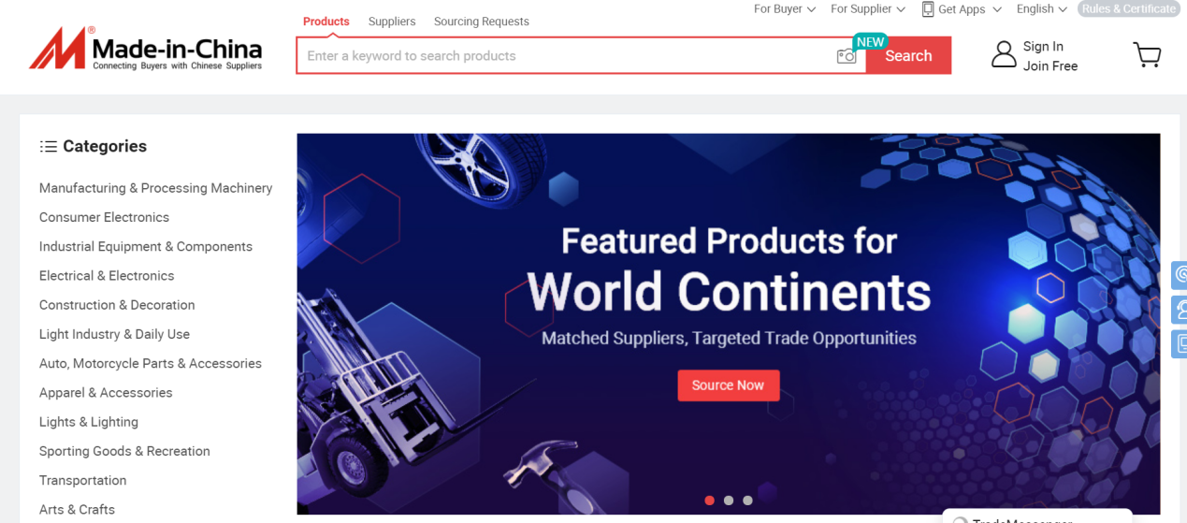

10、**<https://www.amazon.com/>**

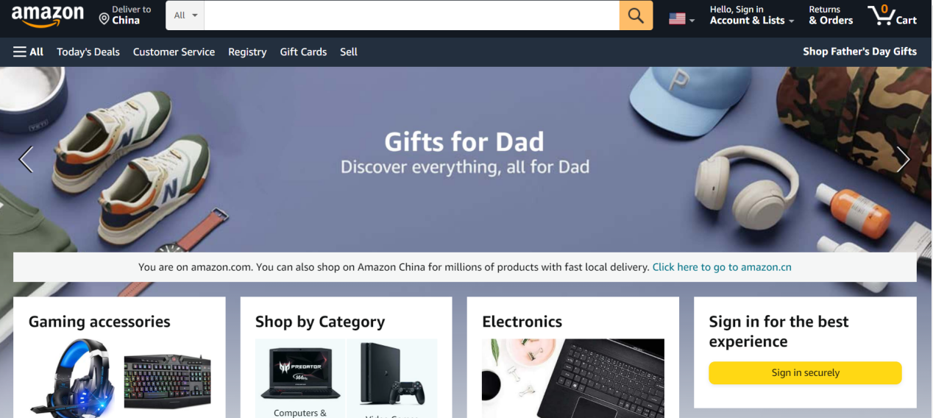

2. Understand the development status and trend of B2B electronic commerceOn the basis of existing research, future research needs to make up for deficiencies in all aspects. Therefore, it is considered that the development trend of B2B e-commerce profit model research is mainly the following three aspects:

（1） Establish a B2B high-level profit model that meets the needs of Chinese customers

Continue to strengthen the evaluation and analysis of the influencing factors and profit strategies of B2B profit model, find out the key to solving the problem of profit model, establish a new

sustainable profit model that meets China's national conditions and meets the needs of customers, and promote the development of B2B e-commerce model to a higher level.

（2） Research on specialized B2B profit model

Continue to strengthen the case study of various specific profit models, summarize the contents, conditions and characteristics of various profit models, so as to seek a new profit breakthrough. Due to the wide coverage of B2B e-commerce, different industries, different market positioning, different operation modes and management systems, there must be differences in their specific profit models. Studying the characteristics of each specific profit model by category is more conducive to the improvement of the profit model, making a comprehensive and systematic analysis of B2B e-commerce, and making B2B e-commerce in related industries develop in a more professional direction.

（3） Improve quantitative analysis means to analyze high-level B2B profit model

Quantitative analysis methods will be more widely used. In the future research, the quantitative research methods will be continuously improved and more widely used. This is the inevitable trend of B2B e-commerce profit model research, because with the continuous deepening of research and the continuous improvement of research level, the level of quantitative analysis will also be improved and widely used, making the future research and demonstration process in this field more rigorous and the research conclusions more persuasive.

3. In view of the success of the B2B enterprise, to analyze the characteristics of the B2B system in the system planning and pattern management, and summarizes the successful elements of the model.

1. large transaction amount

Transactions between enterprises are large in scale and generally large in value. Unlike B2C and C2C, they are mainly consumer goods such as daily use, leisure and entertainment. They are often single transactions with small purchase amount. Compared with B2C and C2C, the number of transactions between enterprises is small, but the amount of each transaction is relatively large, and the e-commerce trading objects among enterprises are relatively concentrated.

2. transaction operation specifications

E-commerce activities among enterprises generally involve complex objects, so the requirements for contract format are relatively standardized and strict, and pay attention to the effectiveness of the law. The conditions of e-commerce among enterprises are relatively mature. B2B ecommerce model is the mainstream of e-commerce development in the future, and has great development potential.

3. complex transaction process

E-commerce activities among enterprises generally involve multiple departments and personnel at different levels. Information exchange and communication are more frequent, and the control of the transaction process is more strict.

4. wide range of trading partners

B2B is just a trading platform that brings together both sides of the transaction and provides a bridge for both sides of the transaction. The types of commodities traded are not limited by online transactions.

Generally speaking, B2B e-commerce refers to that both the supplier and the demander of e-commerce transactions are merchants. They use Internet technology or various online commerce platforms to complete all or part of the processes of supply and demand information release, business negotiation, ordering and order confirmation, contract signing, payment for goods, Bill issuance and receipt and delivery, goods distribution and monitoring in business transactions. It is also B2B e-commerce. The manufacturing or commercial departments engaged in product operation are mainly e-commerce activities between enterprise supply chain partners, while the departments engaged in service operation involve a wide range of B2B e-commerce contents, such as business opportunity information services, financial services, advertising services, design services, etc.

1. Reduce procurement costs:

Enterprises and suppliers shall establish a virtual trading platform to realize online procurement and reduce the human, material and financial resources invested by both parties. Purchasers can purchase from suppliers uniformly by sorting out the enterprise's internal purchase system to obtain discounts.

2. Reduce inventory costs:

Enterprises and suppliers establish a virtual trading platform to determine supply based on production according to the sales rated output, realize the effective operation of logistics and control inventory.

3. Save turnaround time:

Enterprises and suppliers establish a virtual trading platform to realize direct communication between supplier enterprises and customers and reduce intermediate links.

4. Expand market opportunities:

Establish business relations with potential customers on the network, cover the network market, and increase the sales opportunities of enterprises.

5. Large scale and strong competitiveness:

The website provided by the enterprise is an information release platform, and the information is directly provided by the manufacturer with rich content.The newly established website has a complex structure and needs a strong SEO optimization team to maintain, which is still guaranteed for the later optimization. These websites are often an enterprise station, and the scale is not at the same level.

**2.4 Questions**

1、How do you think the future of B2B prospects?

At present, B2B e-commerce has formed a relatively perfect industrial ecology. With the help of policies, the enthusiasm of small and medium-sized enterprises to carry out e-commerce has increased. B2B e-commerce platform will achieve revenue growth by providing more value-added services.

Internet plus: with internet plus action continuing to deepen, B2B electricity market has made efforts to segment the field. Energy, chemical, agricultural and cross-border have become the key areas.

2、What type of measures can be taken to carry out effective e-commerce management?

Commerce management method is an important tool and means to realize the effective management of e-commerce activities. Therefore, we should discuss the system method of e-commerce management from the core content of e-commerce activities, recognize and use

3、What are similarities and differences between B2B Marketing and B2C Marketing?

First of all, B2B marketing and B2C marketing have a common system in terms of knowledge, principle and theory. In B2B marketing and B2C marketing activities, the basic tasks of management are the same. No matter in the enterprise market or in the final consumer market, the marketer should make the organizational plan guided by the market, which requires the marketer to better understand and meet the consumers.

There are great differences between B2B market and B2C market. For example, the number of customers in B2B market is small, but the purchase amount is large; customers are often special and complex, and there are many people who participate in the purchase and the purchase process is rational and professional.

B2C marketing focuses more on the function of products and the after-sales service of manufacturers, while B2C marketing focuses on the brand and price of brands or services. In terms of market segmentation, B2B is subdivided according to the needs of industries and individual companies, while B2C is subdivided according to the needs of individuals or group.

**Experiment 3: Net marketing**

There are so many e-marketing ways, here are some of them. Just choose three or more to complete, but you have to answer the questions. Draw the transaction flow diagram（business process diagram） in your experiment report. It would be appreciated that if you can provide detailed steps and screenshots.

**3.1 SEM( Search Engine Marketing)**

Baidu Union is a network advertising alliance. It is an advertising agency. On the one hand, it undertakes advertising business, and on the other hand, it invests advertising in various websites. Relying on the world's largest Chinese search engine, Baidu Union provides highly competitive professional services for Internet traffic realization, with tens of billions of daily advertising shows, more than 800000 advertisers, nearly one million partners and an annual share of more than 20 billion.

Step1: Click “Registration”. Follow the instruction and fill the required information.

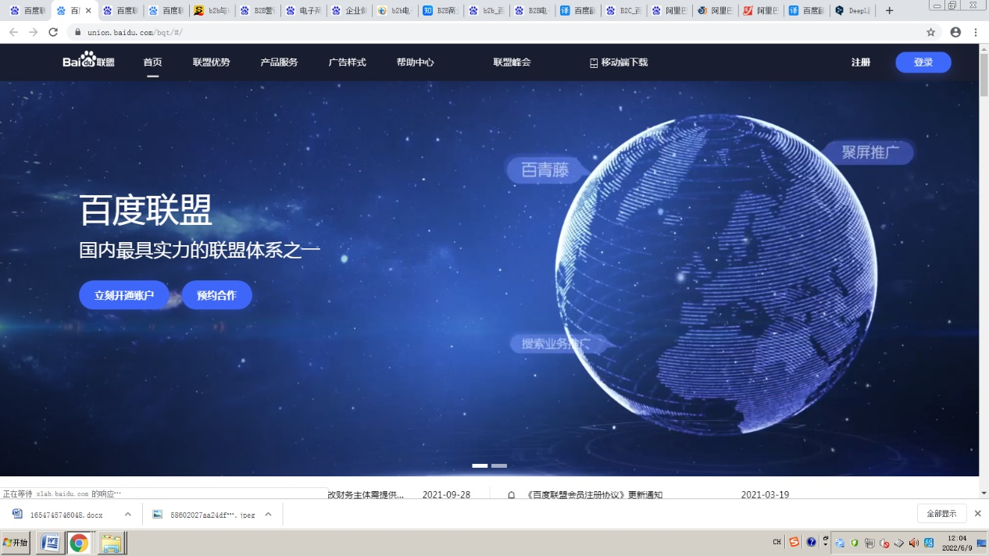

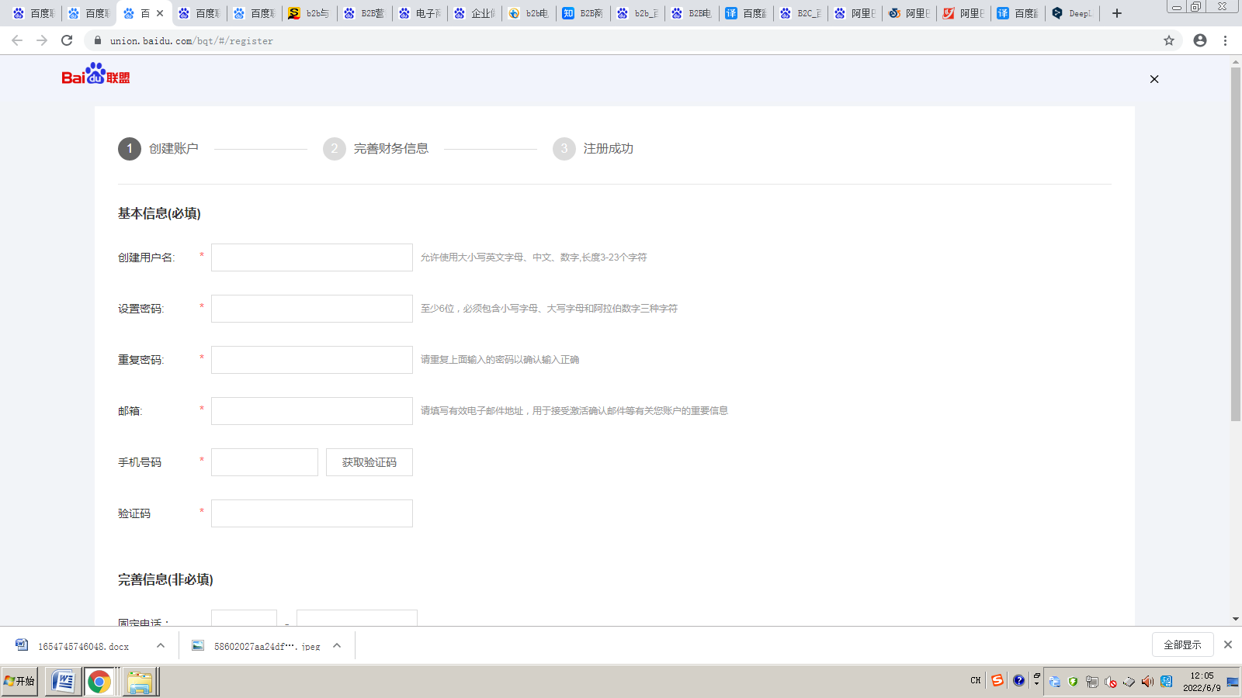

Step2: Verify the email

You can see the prompt, check the email again a day later, if you pass, you can add the advertisement

**3.2 SNS(Social Networking Services) marketing**

Step1: Select target clothes from the store as a base to write the soft article.

Step2: Edit soft article on weibo and add #hashtag# to highlight the brand name.

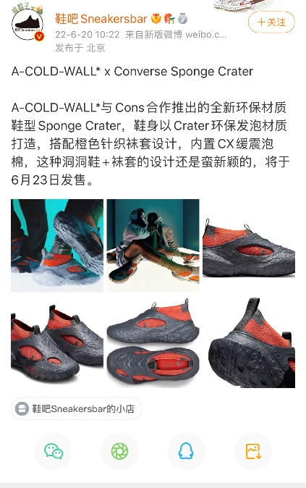

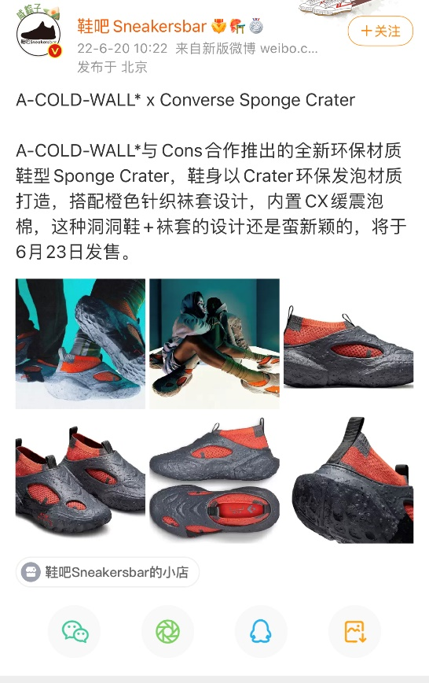 Step3: Post the article on Weibo (Be aware of the limit of the words, pictures number)

The role and status of enterprise marketing strategy

Marketing planning can make clear the goal that the enterprise should achieve in the future. Through marketing planning, enterprises can establish clear marketing objectives. It can not only accelerate the transition of enterprise marketing from the real state, but also reduce the ineffective labor caused by many detours to find the target. Marketing planning can also help enterprises to better win the market competition. Take make up products promotion as an example, because most of the people who can make up are women, and most of them are young people who are active on social platforms, so the target customers of our social network marketing programs are young women, especially female college students and new women in the workplace.

If we do make-up at a low price, ask stars to give us publicity on these platforms, which will obviously lead to high marketing costs. Therefore, we can choose some influencers specialized in cosmetics promotion or fashion to promote our products in the way of articles or videos. Finally, we can analyze the social network comment information, and indirectly measure the overall change trend of social network marketing effect by analyzing the change trend of user comment's word-of-mouth

**3.3 IM (Instant Messenger)** **marketing**

Step1: Send the link to the messenger.



Step2: Click the link and scan the product.



2. What do you think of IM marketing? Give an example to explain.

IM marketing is an important means of network marketing, an effective tool for business opportunity mining, online customer service and virus marketing, and another important method after e-mail marketing and search engine marketing.

Wechat is to spread the whole activity through people's Psychology ("self-interest + altruism"), and then use the coupons in the red envelope to promote users' consumption, so as to drive the sales of the whole platform. This kind of activity can be carried out for a long time. People have a long-term demand for frequently used vouchers, but the cost is high.

**3.4 CPS (Cost Per Sales)(for international students ,if you cannot understand Chinese, you can omit this part)**

In china, there are some good CPS unions, such as

taobao union: <http://alimama.com>

baidu union: [http://union.baidu.com](http://union.baidu.com/)

**Tips:**

You need provide some detailed steps and screenshots.

Step1: Sign in

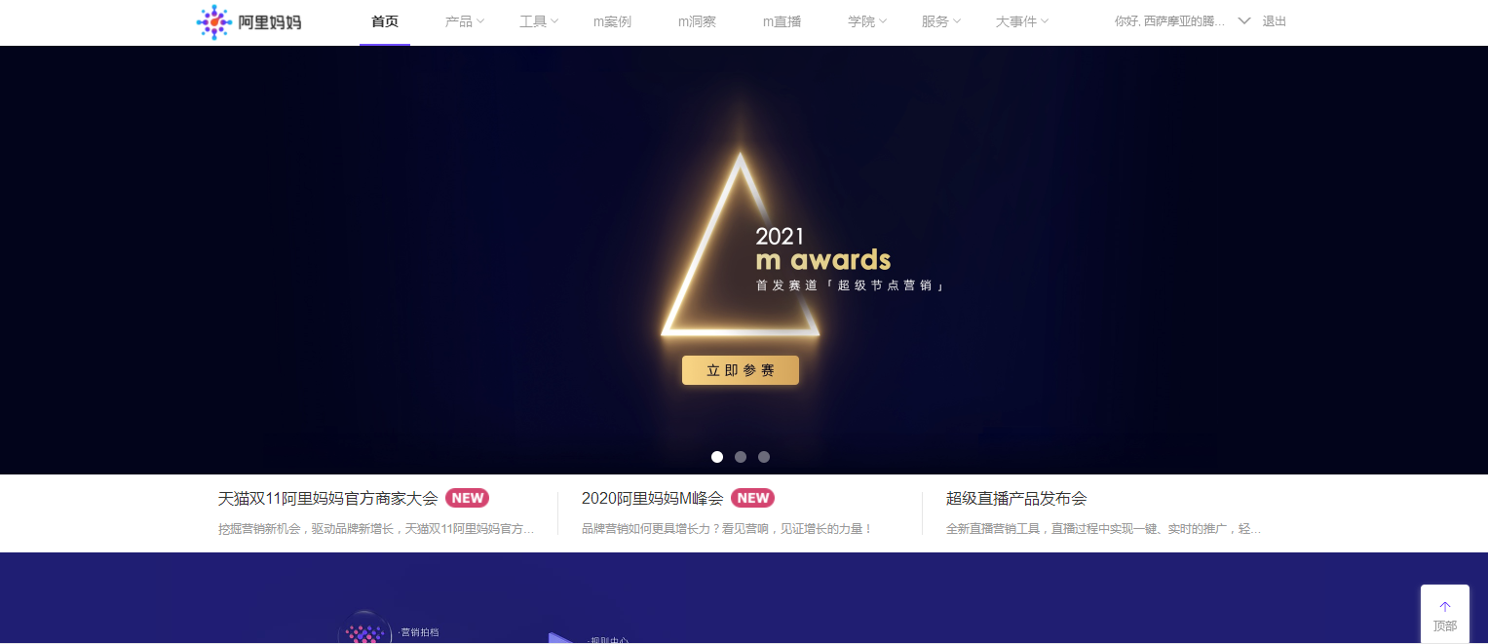

Step2: click the “sheng tai huo ban” in “Product”

Step3:Register and Enter the back platform。





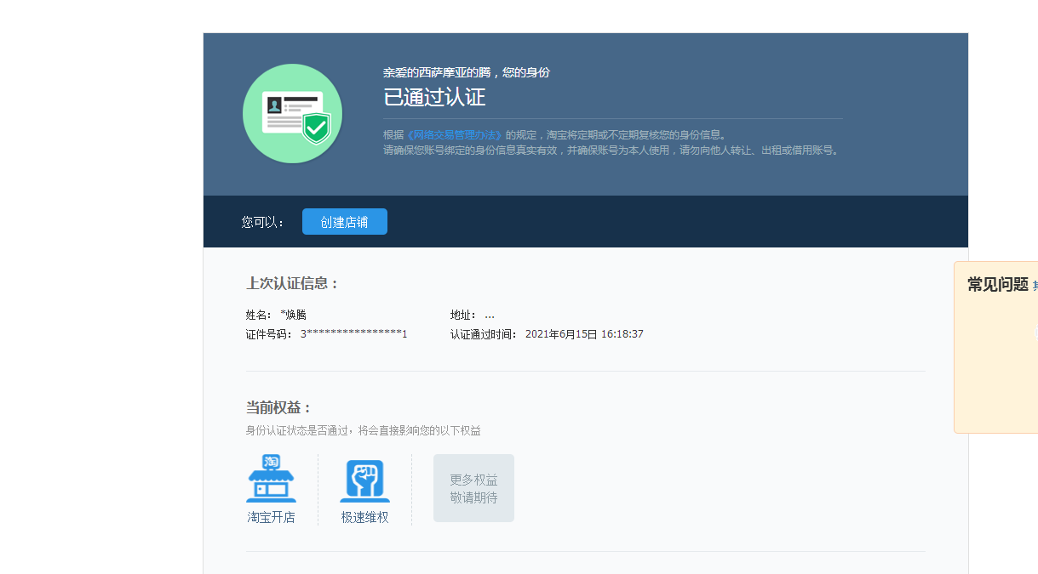

Step4: Choose the product that you want to promote

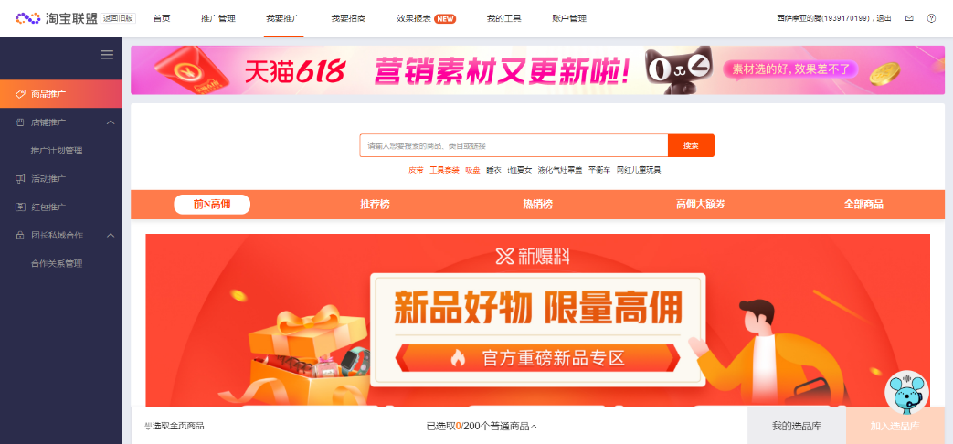

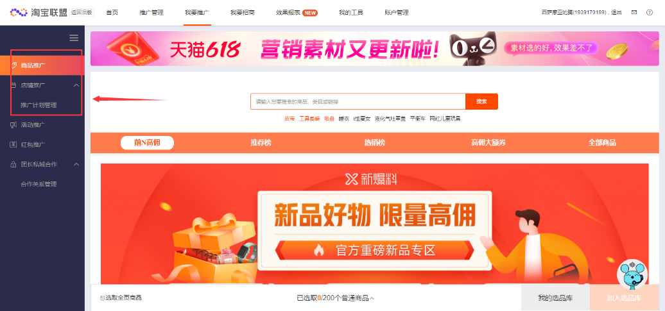

Step5: Click the product and add to the storage



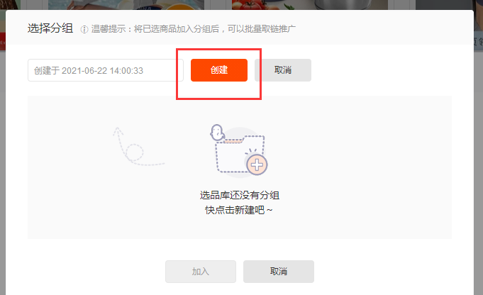

Step6: Click the mass marketing. Choose the type and the platform of your marketing.

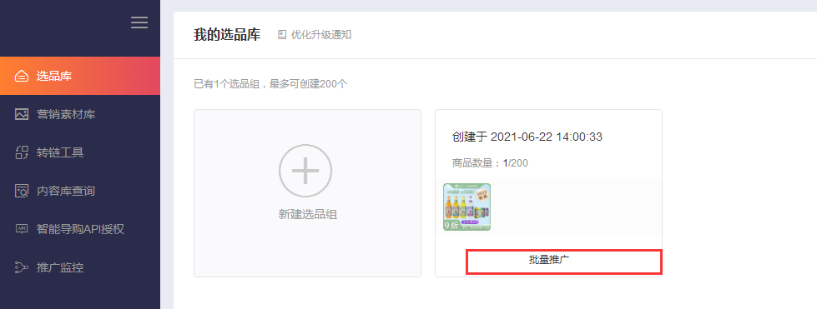 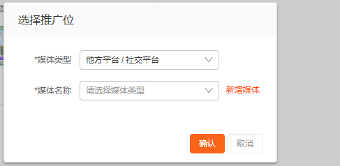

 Step7: Finished the marketing.

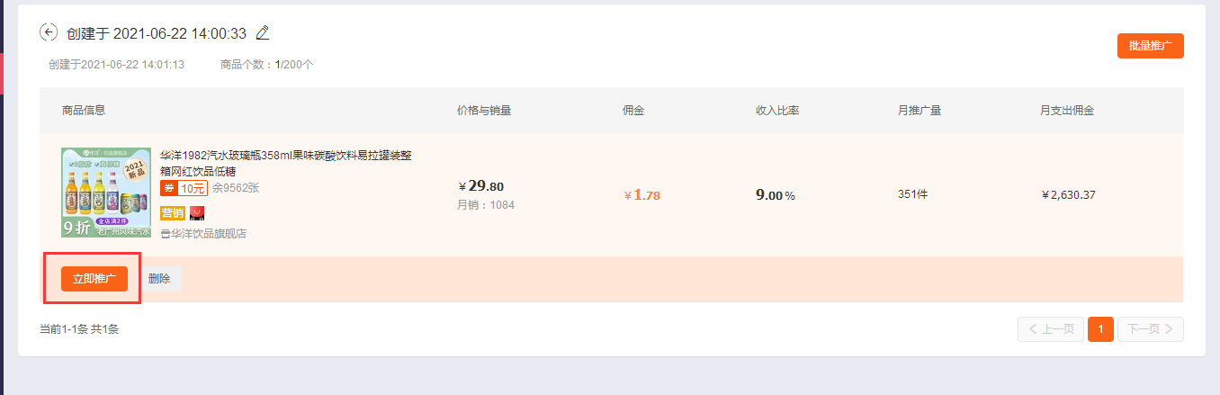

**3.5 Questions**

**1. What is the Search Engine Marketing?**

Search Engine Marketing: English Search Engine Marketing, we usually referred to as "SEM". To put it simply, search engine marketing is network marketing based on search engine platform, which makes use of people's dependence on and usage habits of search engine to deliver information to target users when people search for information. The basic idea of search engine marketing is to let users find information, and click into the web page, to further understand the information needed. Enterprises pay for promotion through search engines, so that users can directly communicate with the company's customer service, understanding, to achieve transactions. SEM methods include SEO, paid ranking, accurate advertising and paid inclusion, etc.

**2. What kind of web pages do the search engine spiders like?**

(1)Page loading speed

Page loading is more important for search engine spider friendliness. If you can't open the site when the spider arrives, the spider experience will be very unfriendly and will reduce the number of subsequent visits. However, the server can improve the site loading speed, in a safe and stable environment, the server is the site construction should choose a good. Therefore, if the server is unstable, we should contact the space service provider in time and load the Web application into a space with relatively perfect comprehensive performance, which is convenient for THE daily operation of SEO.

(2)Reduce flash usage

SEO optimization needs to pay attention to whether the page layout has flash animation. Spiders recognize images, and if a site has less text on its page, it will lose priority in the ranking. Therefore, the organization and layout of the page frame should be friendly and beautiful, and the use of frame structure should be careful.

(3)Barrier-free web browsing

URl scraping refers to static or pseudo-static websites. This website structure is a convenient search engine spider structure model. If there are too many parameters, the data will directly generate dynamic paths, and dynamic paths are not friendly behavior for search engines, especially dynamic paths with Chinese parameters, search engines are very dislike.

(4)The original content is very popular

Baidu has been cracking down on fake original content, but also focuses on optimizing original content, so many websites that collect articles rank poorly. However, they are full of creativity, rich in content and valuable. That's what search engines love.

(5)Keep it simple

Search engine pages do not need too much code, as long as the page content is concise, page structure is conducive to optimization, each title column can guide the spider it wants to go to the place, and then the site is high quality, so the concise layout of the page is the location of each layout.

**3.Give an example to describe what is the CPC(COST PER CLICK).**

Cost Per Click (CPC), sometimes referred to as Cost Per Thousand click-through, is charged on a per-click (or per-thousand clicks) basis. For advertisers, avoiding the risk of only browsing advertising without clicking is one of the common charging methods in mature countries. For example, if the price per click of an advertisement is 0.5 yuan, CPC=0.5. If you're willing to pay $0.5 to get people to visit your site, set $0.5 as the maximum click bid. When a person reads an AD and clicks on it, you will have to pay up to 0.5 yuan for the AD. Of course, if they don't click, you don't have to pay anything.

**4.Give an example to differentiate CPC and CPS.**

CPS is Cost Per Sales. CPS is actually a kind of advertising. Advertising costs are calculated based on the actual number of products sold, which is the most direct effect marketing advertising. CPS advertising Alliance uses this billing method to place advertisers' ads on numerous websites. CPS applies to goods with web pages that can be viewed and paid for on the Internet. Such as C2C website (Taobao, Eachnet, youah, paipai, etc.) and B2C website goods.

**5.Briefly describe what Search Engine Optimization is.**

SEO (Search Engine Optimization) is a method of using the rules of Search engines to improve the natural ranking of a website within the relevant Search engines. The goal is to take a leading position in the industry and reap brand benefits. It is largely a business practice by web site operators to move themselves or their companies up the rankings.

The technical means of search engine optimization mainly have black hat, white hat. Those who cheat search engines and visitors by cheating are called black hats, such as hiding keywords, creating a large number of META words, Alt tags, etc. And through the formal technology and way, and by the search engine accepted SEO technology, known as the white hat.

The white hat approach to search engine optimization follows the acceptance principle of search engines. Their advice is generally to create content for users, make it easy for search engine bots to index, and not game search engine systems. The white hat method can find and correct errors made by staff in designing or building their site, such as machine-readable menus, invalid links, temporary redirection, inefficient index structures, etc.

Black hat methods use deceptive techniques and abuse of search algorithms to promote unrelated, mainly business-focused web pages. The main purpose of black hat SEO is to get a site the rank they want and get more exposure, which can lead to unsatisfactory search results for the average user. So when search engines find a site using black hat technology, they can either lower its ranking or, at worst, strip it from their search results forever. Choose black hat SEO service businesses, partly because they do not understand technology, in the absence of understanding the value of SEO is cheated by service providers; The other part only pay attention to the short-term profit, there is a profit and leave mentality.